Plan Your 2016 CPA Marketing Now.  2016 Accounting Shows in NY, NJ, CA, IL | Flagg Management Inc  353 Lexington Avenue  New York, NY 10016  Tel. (212) 286-0333  Fax (212) 286-0086  www.flaggmgmt.com  flaggmgmt@msn.com
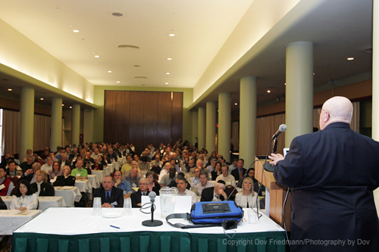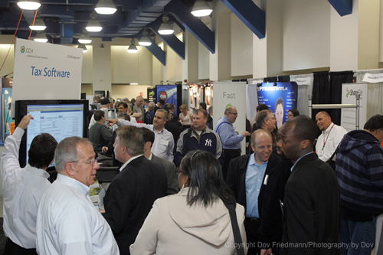
Plan your 2016 CPA marketing now.

2016 Accounting Shows in New York, New Jersey, California, Illinois

Submit your application today.
www.flaggmgmt.com

Plan your 2016 CPA marketing now in New York, New Jersey, California and Illinois.

Each State-sponsored show will assemble CPAs and accounting professionals that you will want to meet and sell on a person-to-person basis.

CPAs will be there to see the exciting show floor, network with their peers, and attend low-cost CPE conference programs.
Floorplans for all shows are online. The 2016 floorplans are the same as the 2015 floorplans.
Past 2015 exhibitors and sponsors in each of show will have priority in space assignments for 2016.
The 4 events for 2016 are:
2016 8th Annual New York Accounting Show, July 13-14, Weds-Thurs, Penn Plaza Pavilion, Pennsylvania Hotel, New York, NY. Set-up Tues, July 12. $2,500/booth
Sponsored by the National Conference of CPA Practitioners (NCCPAP)
www.flaggmgmt.com/ny 1,100 Accounting Professionals in attendance.
2016 22nd Annual New Jersey Accounting Show, May 18-19, Weds-Thurs, Meadowlands Exposition Center, Secaucus, NJ. Set-up Tues, May 17. $2,200/booth
www.flaggmgmt.com/nj 1,200 CPAs and Business Professionals in attendance.

2016 32nd Annual California Accounting Show, June 1-2, Weds-Thurs, Los Angeles Airport Hilton Hotel, Los Angeles, CA. Set-up Tues, May 31. $3,200/booth
Sponsored by the California CPA Society
www.flaggmgmt.com/ca 1,600 CPAs and Business Professionals in attendance.
2016 36th Annual Midwest Accounting Showcase, Aug 23-24, Tues-Weds, Stephens Convention Center, Rosemont, IL. Set-up Mon, Aug 22. $2,500/booth
Sponsored by the Illinois CPA Society.
www.flaggmgmt.com/icpas 1,800 CPAs & Business Professionals in attendance.

Russell Flagg
Flagg Management Inc
353 Lexington Ave
New York NY 10016
P: 212-286-0333 F: 212-286-0086
2016 New York, New Jersey, California, and Illinois Accounting Shows
Act now. This is a non-binding application for exhibitors. A complete package of services is provided in booth rental.
Yes, hold space:

____ 2016 New York Accounting Show, July 13-14, 2016, Weds-Thurs
Weds-Thurs, Set-up Tues, July 12. Penn Plaza Pavilion, Pennsylvania Hotel, New York, NY.
$2,500/booth with complete package of services.
Booth size desired: ____ Single booth____ Double booth____ Island
____ 2016 New Jersey Accounting Show, May 18-19, 2016, Weds-Thurs,
Set-up Tues, May 17, Meadowlands Expo Center, Secaucus, NJ.
$2,200/booth with complete package of services.
Booth size desired: ____ Single booth____ Double booth____ Island
____ 2016 California Accounting Show, June 1-2, 2016, Weds-Thurs,
Set-up Tues, May 31, LAX Hilton Hotel, Los Angeles, CA.
$3,200/booth with complete package of services.
Booth size desired: ____ Single booth____ Double booth____ Island
____ 2016 Midwest Accounting Show, Aug 23-24, 2016, Tues-Weds,
Set-up Mon, Aug 22, Stephens Convention Center, Rosemont, IL.
$2,500/booth with complete package of services.
Booth size desired: ____ Single booth____ Double booth____ Island
Company: __________________________________________________________________
Address: __________________________________________________________________
City: __________________________________ State: ________Zip: ______________
Phone: ______________________________ Fax: ________________________________
Email: __________________________________ URL: ____________________________
Contact Name: _____________________________________________________________
Title: ____________________________________________________________________
Products: _________________________________________________________________
______________________________________________________________________________________

